# **Tool Changer**

## ROBOT YASKAWA HC10DTP

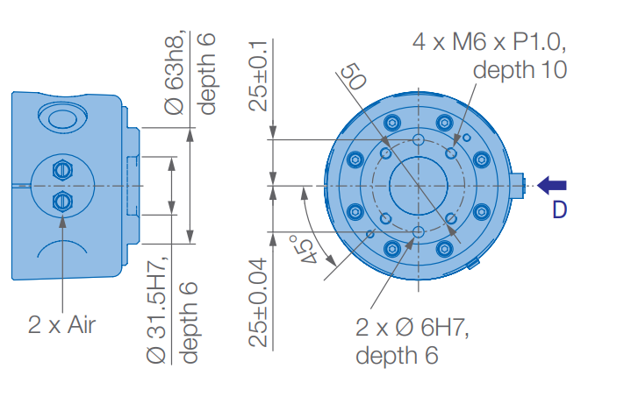

## Gripper- ROBOTIQ 2F85

Electric connections:   
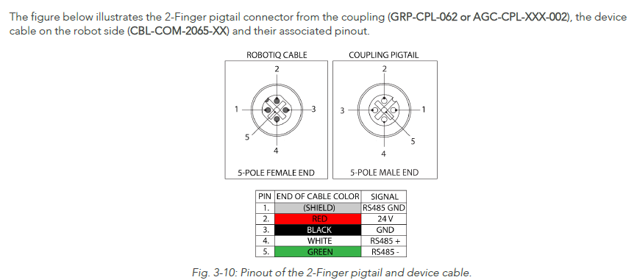

Robot Side

Gripper Side

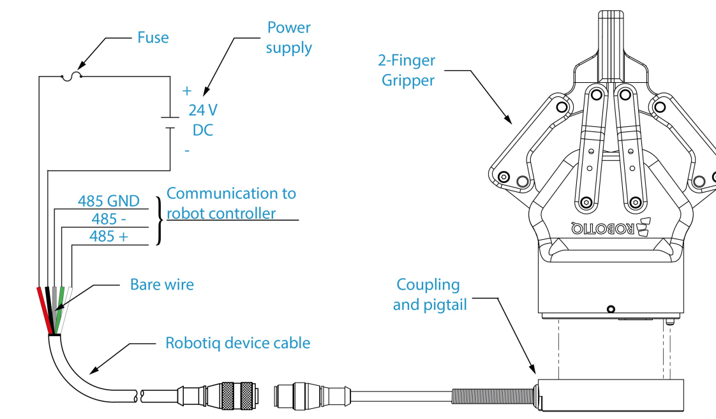

Tool changer will be here.

Mechanical connections:

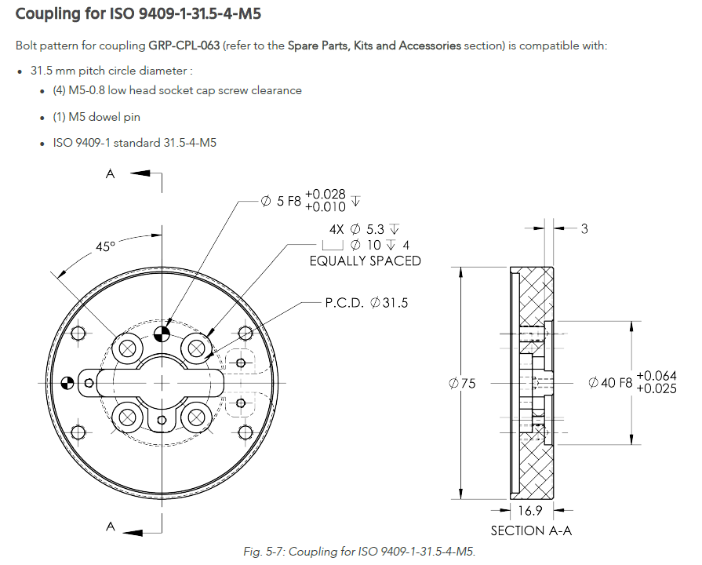

## Scanner - Leica Laser Tracker Automation

Electric connections:  
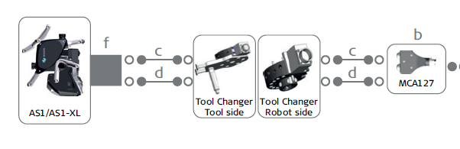

C = M12 GigE Data   
D = M12 Probe Data  
F = Tool Changer

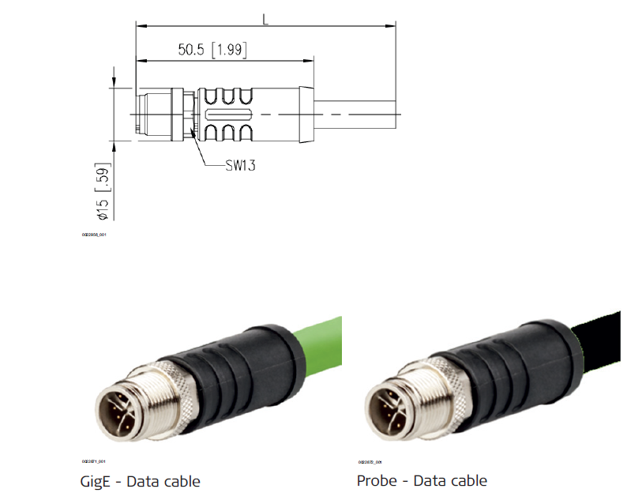

Mechanical connections:

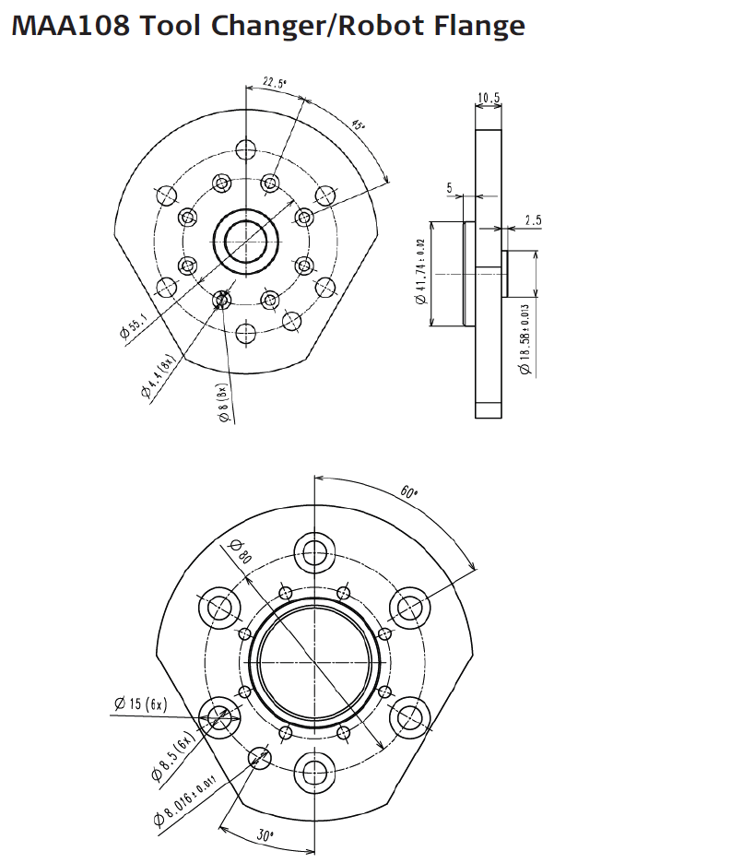

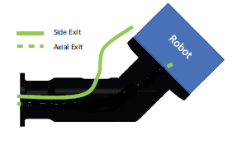

Tool Changer connector with the 2 cables.

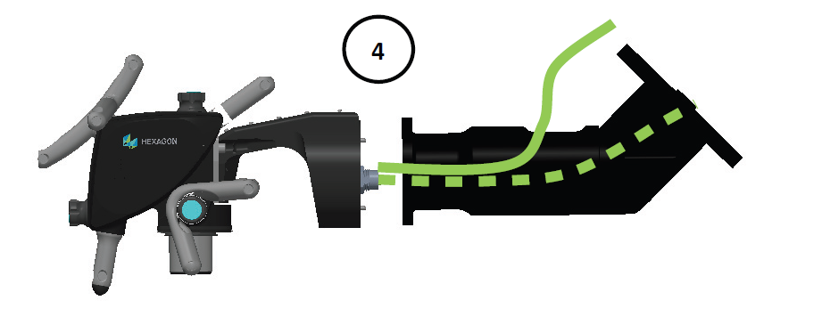

Tool Changer connector with the 2 cables.

The Scanner + Holder is the tool.

## T-MAC

Electric connections:

20 Pin LEMO

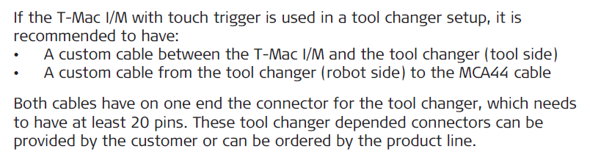

Mechanical connections:

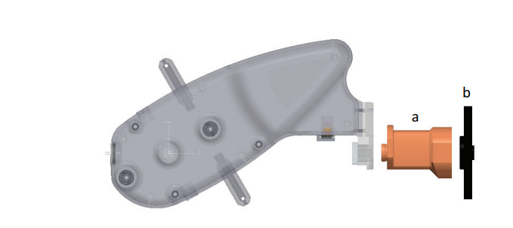

MAA108 Tool Changer/Robot Flange

